## horizontal line



Max-Median Rule

06. April. 2018

**─**

STAT 686 Group 4

Christina Wang, Oliver(Ran) Jin, Rui Qin, Xingyue Zhang

# 

# Introduction

In this project, we want to investigate the effectiveness of the Max-Median Rule, which is a stock-picking strategy, using S&P 500 data from 1970 to 2017. In order to better understand this strategy, we are going to compare the performance of the portfolio created by the Max-Median Rule with the performance of the traditional benchmark S&P 500. Furthermore, we will make some improvements on the Max-Median Rule by changing portfolio size. Overall, our goal is to minimize the variance while maximizing the return. The detailed analysis will be displayed later in the report.

# Data and Methodology

To backtest the Max Median Rule in investing in S&P 500 stocks, we downloaded the daily stock data for the S&P 500 constituents from 1970 to 2017. We downloaded the data from WRDS CRSP - Stock/Security Files - Daily Stock File. The text files with codes of S&P 500 constituents for each year were uploaded to download the daily stock data.

According to the Max-Median Rule, for the stocks in the S&P 500, each year we computed the day-to-day ratio and by looking at the 500 median of the returns, we choose twenty stocks with the largest medians. These stocks are chosen as the “basket” for next year’s investment. At the beginning of each year, we liquidate the stocks invested for the previous year, and invest equally in the new 20 stocks with the largest medians in the previous year. Ideally, the each stock in the portfolio should has the best average performance in the previous year.

The average compounded return of the equally-weighted portfolio of each year is calculated at the end of that year in order to investigate the performance of the portfolio created by the Max-Median Rule. By comparing the profits generated by the Max Median Rule and by the benchmark S&P 500, we could see if this method gives a better return yield than the index.

# Coverage Analysis

The table attached below shows the data coverage. The data coverage is in general quite well, since for all years the data coverage achieves at least 99.99%.

# 

# 

# Analysis

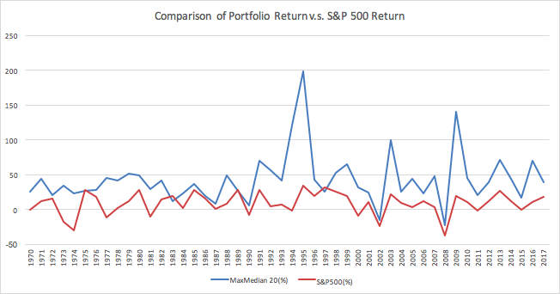

In the figure above, we could see that in the 47 years from 1970 to 2017, the Max-Median Rule outperforms the S&P 500 index. The overall trend for the returns are quite similar. The return calculated using Max-Median Rule outperforms the return calculated using S&P 500. For the Max-Median portfolio, three peaks occurred, while for S&P 500, no there was no dominant peak.

# Improvement

For the analysis above, we use the portfolio size of 20. To improve the performance of the Max-Median Rule, we further tried different portfolio size of 10 and 30. We found out that among N=10, 20, and 30, 10 outperforms 20, 20 outperforms 30. Thus we conclude that n=10 is the optimal improvement we have found.

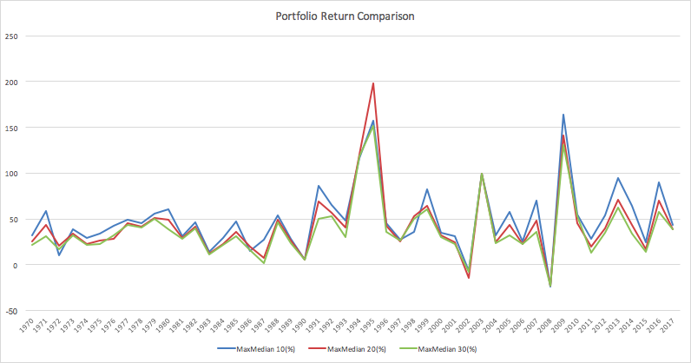

# Conclusion

In this mini project, we compared the performance of the Max-Median Rule with the S&P 500 index. Using the Max-Median Rule, we picked 20 stocks with the highest median returns in the previous year to invest equally for the whole year, and liquidate in the end of the year. We found that the 20 stocks portfolio method performs better than that of S&P 500. By testing different portfolio sizes, we found out that N=10 performs the best.

# Appendix - R Code

data <- read.csv("Rui Qin", header = TRUE)

total = dim(data)[1]

cat("coverage", (1 - sum(is.na(data$PRC))/total),"\n")

data.1 <- data[which(data$PRC!=is.na(data$PRC)),]

data.new <- data.1[which(data.1$PRC>0),]

permno <- c(unique(data.new$PERMNO))

med <- c()

for (i in 1:length(permno)){

permno.price <- c(data.new[which(data.new$PERMNO==unique(data.new$PERMNO)[i]),7])

data.ratio1 <- c()

for (j in 1:length(permno.price)){

data.ratio1[j] <- permno.price[j+1]/permno.price[j]

}

data.ratio <- data.ratio1[1:(length(data.ratio1)-1)]

med[i] = median(data.ratio)

}

A <- as.data.frame(cbind(permno,med))

A$rank <- rank(-A$med)

X <- A[which(A$rank<=20),]

a <- c(X$permno)

R <- c()

for (i in 1:20){

return <- data.new[which(data.new$PERMNO==a[i]),]

R[i] <- (return$PRC[length(return$PRC)]/return$PRC[i])/20

}

cat("for 20 is", (sum(R)-1), "\n")

A <- as.data.frame(cbind(permno,med))

A$rank <- rank(-A$med)

X <- A[which(A$rank<=10),]

a <- c(X$permno)

R <- c()

for (i in 1:10){

return <- data.new[which(data.new$PERMNO==a[i]),]

R[i] <- (return$PRC[length(return$PRC)]/return$PRC[i])/10

}

cat("for 10 is", (sum(R)-1), "\n")

A <- as.data.frame(cbind(permno,med))

A$rank <- rank(-A$med)

X <- A[which(A$rank<=30),]

a <- c(X$permno)

R <- c()

for (i in 1:30){

return <- data.new[which(data.new$PERMNO==a[i]),]

R[i] <- (return$PRC[length(return$PRC)]/return$PRC[i])/30

}

cat("for 30 is", (sum(R)-1), "\n")

# Reference

Thompson, James R., and L. Scott Baggett. *"* *Everyman's MaxMedian Rule for Portfolio Management."* Thesis. Rice University, n.d. pag. Print.